Roles in a Payment System
# Source: AI Source: Provided by: [Data Path: Persons Table -> ID Column: 1, Name_En Column: Motasem Essam] -> From: [ChatGPT] on [1/21/2026]
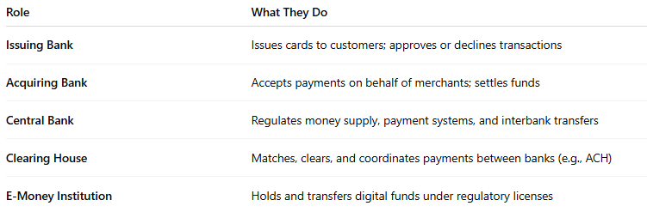

Role | What They Do
Issuing Bank | Issues cards to customers; approves or declines transactions
Acquiring Bank | Accepts payments on behalf of merchants; settles funds
Central Bank | Regulates money supply, payment systems, and interbank transfers
Clearing House | Matches, clears, and coordinates payments between banks (e.g., ACH)
E-Money Institution | Holds and transfers digital funds under regulatory licenses

